**Laboratory 1, 2**

Title of the Laboratory Exercise: Functional, Non-functional and UML diagrams

1. Introduction and Purpose of Experiment

2. Aim and Objectives

Aim

● To develop Functional and Non-Functional requirements, ER diagram, class diagram, interaction sequence diagram and algorithm/flowchart

Objectives

At the end of this lab, the student will be able to

● Model the information required for the given scenario using E-R diagrams

● Develop ER diagram, class diagram, interaction sequence diagram and algorithm/flowchart

3. Experimental Procedure

Students are given a set of instructions to be executed on the computer. The instructions should be edited and executed and documented by the student in the lab manual. They are expected to answer questions posed in section 5 based on their experiment.

4. Presentation of Results

**Scenario:** Student Group Project Management System

**Functional Requirement:**

1. The system should allow the staff to login and students to login/register
2. The system should allow the students to enter their group project details in a form
3. The system should allow the students to register their group project
4. The system should display the room and table no. allotted to the group
5. The system should allow the students to cancel their registration
6. The system should allow the staff to view all the registered group projects
7. The system should allow the students to view the allotted room and table no of a group project
8. The system should allow the staff to cancel a group registration

**Non-functional Requirement**

a) The system must be secure

b) The system must not collapse while handling large number of users

c) The system must be reliable.

**ER Diagram:**

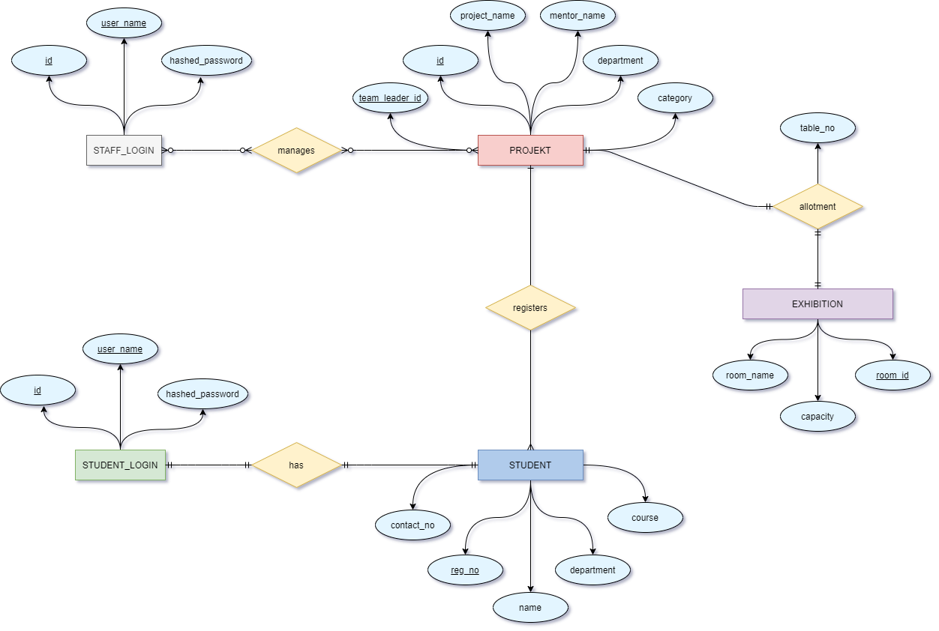

**Relational Schema:**

**STAFF_LOGIN**

|  |  |  |
| --- | --- | --- |
| id | user_name | hashed_password |

**STUDENT_LOGIN**

|  |  |  |
| --- | --- | --- |
| id | user_name | hashed_password |

**STUDENT**

|  |  |  |  |  |  |
| --- | --- | --- | --- | --- | --- |
| fk_id | reg_no | name | department | course | contact_no |

**PROJEKT**

|  |  |  |  |  |  |
| --- | --- | --- | --- | --- | --- |
| fk_team_leader_id | id | project_name | mentor_name | department | category |

**PROJECT_STUDENT_REGISTER**

|  |  |
| --- | --- |
| fk_project_id | fk_student_id |

**EXHIBITION**

|  |  |  |
| --- | --- | --- |
| room_id | room_name | capacity |

**PROJECT_EXHIBITION**

|  |  |  |
| --- | --- | --- |
| fk_room_id | fk_project_id | table_no |

**Class Diagram:**

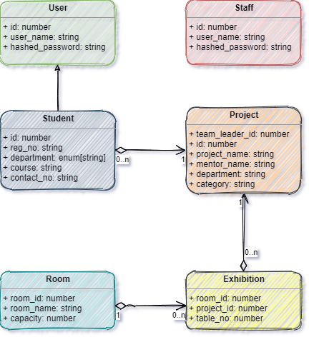

**Sequence Diagram:**

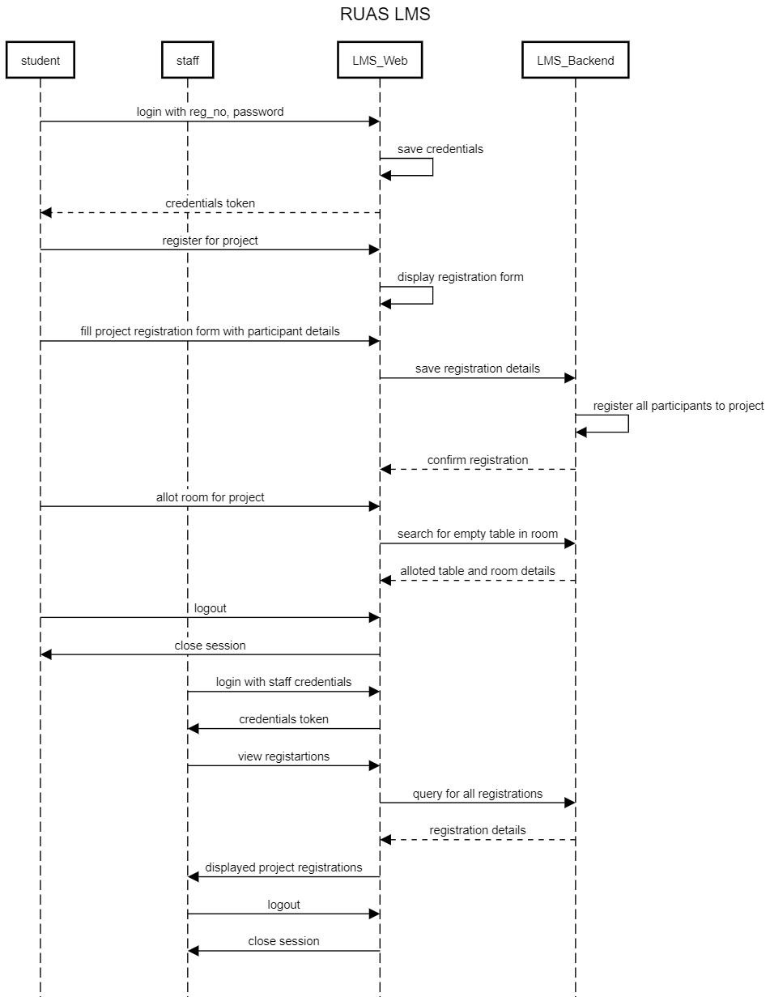

5. Analysis and Discussions

A sequence diagram simply depicts interaction between objects in a sequential order i.e. the order in which these interactions take place. We can also use the terms event diagrams or event scenarios to refer to a sequence diagram. Sequence diagrams describe how and in what order the objects in a system function. These diagrams are widely used by businessmen and software developers to document and understand requirements for new and existing systems. (GFG 2018)

Entity Relational is a high-level conceptual data model diagram. ER modeling helps you to analyze data requirements systematically to produce a well-designed database. The Entity-Relation model represents real-world entities and the relationship between them. It is considered a best practice to complete ER modeling before implementing your database.

6. Conclusions